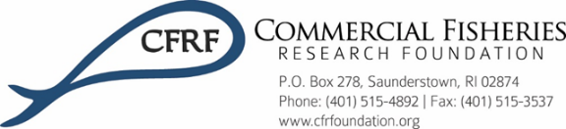

**Pre-Trip Sail Plan Form**

1. **Name of Researchers:**

CFRF- Hannah Verkamp (479-965-5018)

NEU- Katie Lotterhos (850-210-2514), Remy Gatkins (805 704 8877), Jonathan Auguste (516-491-8678)

1. **Vessel Name and Hull Number:**

F/V Ragged Edge, Hull Number 944856

1. **Estimated Time and Date of Departure:**

August 4th, 2021, 7:00 AM

1. **Estimated Time and Date of Return:**

August 4th, 2021, 2:00 PM

1. **Communication of departure and return will be by means of:**

Text to David Bethoney

1. **Communication at sea will occur:**

Text as cellular service allows

1. **If communication breaks down these steps will be taken:**

David Bethoney will attempt to contact all research staff and captain (Derek Pascale, 401-529-4847) via cell phone, if there is no response, he will request the USCG to contact the vessel

1. **Safety Gear:**

PFD, survival suits, foul weather gear, COVID-19 PPE

1. **P-EPIRB Number:**

NA

1. **Emergency Contact Information:**

Hannah Verkamp – Kevin Verkamp, 479-965-6967

NEU researchers- Jonathan Grabowski, 207-841-1408 for all researchers

Katie Lotterhos- Chett Hopkins, 781-715-7853

Jonathan Auguste- Kelly Harlow, 401-441-9968

Remy Gatkins- Dominique Castillo, 617-218-7499

1. **Vessel Contact Information (VMS, satellite phone):**

NA